README 20130570 전철호

제출물: 소스코드, 실행가능파일, 간단한 메뉴얼

소스코드: Please refer to main.py. It is within the zip file I attached, or you can clone it from https://github.com/adobecs5/automata2015/tree/master/1

실행가능파일: please refer to main.py

(how to execute: regardless of OS, open your terminal and type “python3 main.py”)

(This code needs python3 to run. It is coded with python 3.4.3)

간단한 메뉴얼:

1. **Start the program by typing “python3 main.py” on the directory you downloaded the files.**

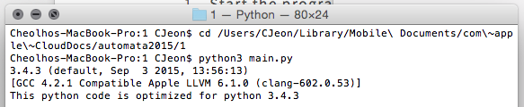

This will automatically print the python version you are on.

If you run this code on python2, you will see the error below



1. **After successfully running the file, you will be asked to provide a datapath for DFA data.**

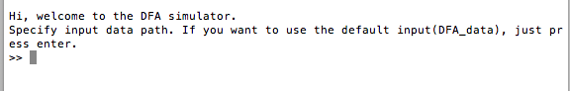

You could either provide your own datapath or choose to use provided test input. Provided tests are in txt formats.

If you input wrong filenames, below error will occur.

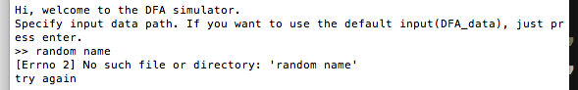

if you input correct filename, below will be printed.

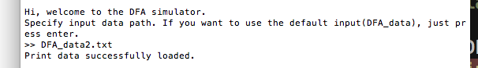

1. **After successfully loading the data, you will be asked to provide an initial state.**



You can just press enter. If you give empty string as input, the program will use predefined start state as initial state.

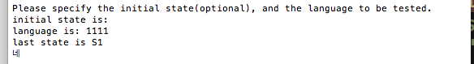

Or you can provide your own initial state.

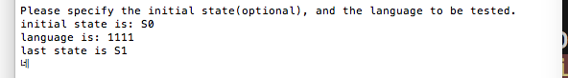

If you provide undefined initial state, you will see the below error message.

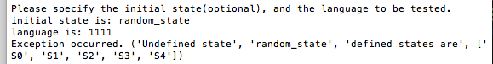

You can also set your own initial state.

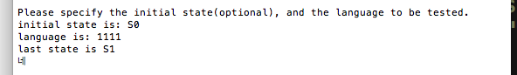

1. **After giving initial state, you will be asked to provide a language to be processed. You can give empty string as an input, which will return the initial state.**

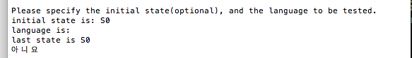

If you give undefined language, the program will return following error

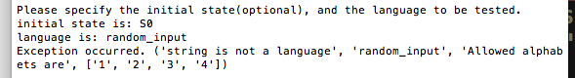

If you provide correct input, the program will execute as follows.

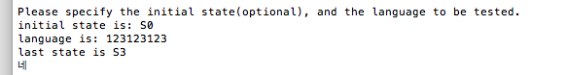

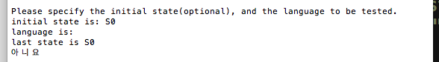

It prints the last state and prints “네” or “아니오” depending on the execution results.

To terminate the program, raise keyboard interrupt in your own terminal.

Thanks for reading so far.